

**Dr. D. Y. Patil Unitech Society’s**

**Dr. D. Y. Patil Arts, Commerce and Science College, Pimpri, Pune 18.**

**RESEARCH WORK REPORT**

**ON**

**“Role of Artificial Intelligence in game development”**

**Developed by**

**Vivek Gunvant Nikam**

**Shubham Pralhad Babar**

**Shubham Vitthal Pawar**

**in partial fulfillment of**

**M.Sc. (Computer Science) Sem-IV**

**Under**

#### **Savitribai Phule Pune University**

#### **2024 - 2025**



**Dr. D. Y. Patil Unitech Society’s**

**Dr. D. Y. Patil Arts, Commerce and Science College, Pimpri, Pune 18.**

**CERTIFICATE**

Exam Seat No.: __________

This is to certify that **Shubham Pralhad Babar (05)** has successfully completed the Research Work entitled **Role of Artificial Intelligence In Game Development** for M.Sc. (**Computer Science) Sem -IV** of Savitribai Phule Pune University for the Academic Year 2024-25.

|  |  |  |
| --- | --- | --- |
| **Project Guide** | **Coordinator** | **InCharge Principal and H.O.D. (Computer Science)** |
| **Internal Examiner** |  | **External Examiner** |

**INDEX**

|  |  |  |
| --- | --- | --- |
| **Sr. No.** | **Details** | **Pg No.** |
|  | Title of Research | 1 |
|  | Certificate | 2 |
|  | Introduction | 4 |
|  | Problem Statement | 5 |
|  | Objectives of the Research | 7 |
|  | Literature Review of previous research in the area | 8 |
|  | Data Collection | 11 |
|  | Working Model | 14 |
|  | Observation | 20 |
|  | Results | 22 |
|  | Future Scope of research | 24 |
|  | Limitation of research | 26 |
|  | Bibliography | 28 |
|  | Reference | 29 |
|  | List of figures | 30 |
|  | Published/ Presented Research Paper Certificate | 36 |

**INTRODUCTION**

In recent years, the integration of Artificial Intelligence (AI) into the game development industry has revolutionized the way digital games are designed, played, and experienced. AI has become a key component in enhancing gameplay mechanics, creating adaptive environments, and delivering more immersive and intelligent user experiences.

This project, titled **“Role of Artificial Intelligence in Game Development,”** explores how AI techniques are applied to different aspects of game creation, such as non-player character (NPC) behavior, environment generation, difficulty balancing, and player prediction. The focus is on understanding how AI-driven systems contribute to creating dynamic and engaging gameplay that responds intelligently to user inputs and decisions.

As part of this project, technologies like **Python** were used for implementing core AI functionalities, while **HTML** and **JavaScript** helped build an interactive front end. **Stockfish** and **Lc0** — two powerful open-source chess engines — were integrated to simulate intelligent gameplay and evaluate game strategies in real-time. These engines enabled us to create a smart, self-learning opponent in chess-like games. Additionally, **Ngrok** was used to create secure tunnels for local testing and web deployment, allowing real-time access and multiplayer interaction from remote locations.

The implementation involves the use of machine learning algorithms, pathfinding techniques (like A*), and behavior trees to model intelligent decision-making. AI is also leveraged for analyzing player behavior and adapting the gameplay accordingly to deliver personalized experiences.

The system is designed to showcase:

* Real-time adaptive decision-making by AI agents.
* Interactive gameplay using integrated chess engines.
* Responsive user interfaces supported by web technologies.
* Online multiplayer features enabled through secure tunneling tools.

In essence, this research demonstrates the transformative impact of Artificial Intelligence in the field of game development, emphasizing its role in pushing the boundaries of creativity, realism, and player engagement in today’s gaming landscape.

**Problem Statement**

Modern game development is rapidly evolving, but creating intelligent, immersive, and personalized gameplay still poses several challenges. Traditional games often rely on scripted behaviors, predictable environments, and static difficulty levels, which can reduce player engagement over time. There is a growing need for games that respond dynamically to player actions, offer intelligent opponents, and simulate real-world decision-making using advanced AI techniques.

Although many game engines and frameworks exist, they often lack deep AI integration or require extensive manual coding to simulate even basic intelligent behavior. Moreover, building games that can adapt in real-time, analyze player behavior, or host intelligent gameplay remotely remains complex and resource-intensive.

The key problems identified are:  
• **Lack of Realistic AI Behavior**: Many games feature NPCs or opponents that follow repetitive or easily predictable patterns.  
• **Limited Personalization**: Traditional games rarely adapt to different player styles or skill levels dynamically.  
• **Static Game Mechanics**: Without AI, most games cannot simulate learning, strategy, or complex decision-making.  
• **Complex Development Workflow**: Integrating AI into games requires deep technical knowledge and multiple tools.  
• **Limited Accessibility for Real-Time Testing**: Testing intelligent gameplay remotely or collaboratively is not always seamless.

This project aims to address these issues by building a smart, AI-powered gaming experience that:

1. Uses **Stockfish** and **Lc0** to simulate intelligent decision-making in strategy-based games like chess.
2. Implements **Python** for AI logic, game rules, and backend processing.
3. Utilizes **HTML** and **JavaScript** for an interactive and user-friendly game interface.
4. Employs **Ngrok** for remote access and real-time multiplayer testing.
5. Demonstrates adaptive and strategic gameplay through AI that can analyze and respond to player moves.

By developing this system, the goal is to showcase how Artificial Intelligence can enhance game development by offering smarter opponents, personalized gameplay, and dynamic interaction—paving the way for more engaging, educational, and intelligent digital games.

**OBJECTIVES OF RESEARCH**

The primary objective of this research is to design and develop an intelligent game system that demonstrates the integration of Artificial Intelligence (AI) to enhance gameplay experience, simulate smart opponents, and create dynamic, personalized interaction. The project aims to showcase how AI techniques and tools like **Stockfish**, **Lc0**, **Python**, **HTML**, **JavaScript**, and **Ngrok** can be used to build engaging and realistic games.

**Specific Objectives:**

1. **To Develop an AI-Based Game Engine**  
   Integrate powerful AI engines like **Stockfish** and **Lc0** to simulate intelligent opponents capable of real-time strategic decision-making.
2. **To Implement Smart Decision-Making Systems**  
   Use AI algorithms such as Minimax and behavior trees to model adaptive gameplay that responds to player actions and strategy.
3. **To Build an Interactive and Responsive Game Interface**  
   Design a clean, browser-accessible game UI using **HTML**, **CSS**, and **JavaScript**, providing an engaging experience for users.
4. **To Integrate AI Logic with a Robust Backend**  
   Use **Python** for backend logic, game rule enforcement, and AI processing to ensure smooth and intelligent gameplay.
5. **To Enable Real-Time Remote Access and Testing**  
   Utilize **Ngrok** for creating secure tunnels that allow users to play and test games remotely with minimal setup.
6. **To Personalize Gameplay Based on Player Behavior**  
   Incorporate analytics and adaptive mechanics that change difficulty or response patterns based on user interactions.
7. **To Simulate Human-Like Opponents**  
   Provide a gaming experience where the AI behaves like a real player—analyzing moves, making predictions, and reacting accordingly.
8. **To Simplify AI Game Development for Educational Use**  
   Demonstrate how complex AI systems can be built and used in game development, serving as a learning resource for students and developers.

**LITERATURE REVIEW**

The integration of Artificial Intelligence (AI) in game development has radically changed how games are designed, played, and experienced. AI not only powers intelligent non-player characters (NPCs) but also enhances player engagement, adapts gameplay dynamically, and introduces strategic depth. This literature review highlights five influential studies and technologies that align closely with our project, which incorporates AI-driven engines like Stockfish and Lc0, alongside Python, HTML, JavaScript, and Ngrok, to build a modern, interactive chess-based web game.

**1. “Artificial Intelligence in Games: A Survey”**  
**Authors:** Georgios N. Yannakakis, Julian Togelius  
This survey presents an in-depth look at how AI is integrated into games across multiple domains including behavior modeling, procedural content generation, and adaptive difficulty. It discusses classic techniques like finite state machines and A* pathfinding, along with newer strategies like deep reinforcement learning and genetic algorithms. Particularly valuable to our project is the emphasis on player modeling and adaptive AI, which supports the idea of customizing AI opponent strategies based on the user's skill level. It reinforces how AI is no longer a background element but an active part of gameplay design that enhances immersion and replayability.

**2. “Stockfish Chess Engine and Its Impact on AI-Driven Game Strategies”**  
**Authors:** Community of Contributors  
This paper (from the open-source documentation and developer discussions) focuses on how **Stockfish**, one of the most powerful chess engines, uses alpha-beta pruning, bitboard evaluation, and position scoring to make intelligent decisions. It shows how AI can achieve superhuman performance through brute-force analysis combined with heuristics. In our project, Stockfish is used as the main engine to challenge players, and its advanced position evaluation is leveraged to offer move suggestions or analysis — making the game educational as well as entertaining. This engine brings the rigor and intelligence of professional-level chess to our web application.

**3. “Leela Chess Zero (Lc0): Deep Neural Network Approach to Chess”**  
**Authors:** Leela Chess Zero Development Community  
Lc0, inspired by AlphaZero, is a neural-network-based chess engine that learns entirely through self-play without pre-programmed rules. Unlike Stockfish, it evaluates positions using a policy-value network trained on millions of games. This approach gives Lc0 a more “human-like” and strategic feel, often favoring long-term planning over short tactical gains. Including Lc0 in our project gives users the option to play against a learning-based opponent, offering variation in gameplay and highlighting the contrast between brute-force search (Stockfish) and pattern-based decision-making (Lc0). This dual-engine setup showcases two core AI paradigms in game AI development.

**4. “AI-Powered Web Games Using Python ”**  
**Authors:** S. Parthasarathi, R. Kumar  
This paper provides insights into the architecture of web-based AI games using **Python** and **JavaScript**. It explains how RESTful APIs can connect the frontend with the AI backend in real time. The authors demonstrate lightweight deployment strategies and explore how frameworks like Flask can handle asynchronous gameplay data efficiently. For our project, we adopted a similar client-server model, enabling the web interface to communicate with AI engines and deliver moves instantly. The use of **Ngrok** further allows temporary public access for testing or live matches without requiring complex hosting solutions. This architecture ensures scalability and real-time performance.

**5. “The Role of Machine Learning and AI in Modern Game Design”**  
**Authors:** John Smith, Clara Becker  
This study highlights how AI is not just a technical feature but also a design tool in modern games. It explores how game designers use machine learning to create dynamic difficulty adjustment (DDA), personalized gaming experiences, and smarter NPC behavior. The paper also emphasizes the need for ethical AI use, ensuring fair play and player privacy. In our project, we draw inspiration from this research to create an engaging and intelligent opponent system that adapts to player inputs and can offer move hints, learning feedback, and varied responses — making the game feel less static and more like a personalized challenge.

These studies collectively reinforce the evolving role of AI in game development and validate our use of tools like **Stockfish**, **Lc0**, **Python**, **Flask**, **HTML/CSS/JavaScript**, and **Ngrok** to create an intelligent, accessible, and responsive gaming platform. The blend of deep learning, classic AI, and real-time web integration provides both depth and versatility, reflecting the future direction of smart, interactive games.

**DATA COLLECTION**

For any AI-driven system, especially one designed to enhance game development, the success of its algorithms and interactions relies heavily on the quality and diversity of data used for training and testing. In the context of game development, where AI powers NPC behavior, dynamic gameplay, and adaptive environments, it is crucial to gather comprehensive, relevant, and ethically sound data. The data collection process was meticulously carried out to ensure that the AI models receive accurate, context-rich information, enhancing the realism, adaptability, and intelligence of the game’s interactive elements.

#### 1. **Sources of Data**

The data for this project was collected from a range of carefully selected sources, ensuring diversity and relevance to the intended AI applications within the game:

* **Game Databases and Libraries**: Platforms such as **OpenAI Gym**, **Unity Asset Store**, and **Unreal Engine Marketplace** were vital in providing diverse datasets for NPC behaviors, movement patterns, and environmental interactions. These sources also included pre-designed game mechanics, such as combat systems and NPC decision-making trees, which helped form the foundation of the AI models that would later be applied in games. Data collected from these sources was crucial for understanding how different environments affect AI decisions and how AI can learn and adapt based on these stimuli.
* **Game Design Documents and Player Feedback**: Game design documents were used to define gameplay mechanics, character behaviors, and world-building principles. These documents provided the foundational understanding of how players are meant to interact with the game, allowing AI models to be designed with these interactions in mind. Furthermore, player feedback was obtained from community-driven platforms such as **Steam** and **Reddit**, where discussions and reviews of various games offered insights into how players react to AI behaviors. This feedback helped refine NPC decision-making algorithms to align more closely with player expectations and behaviors.
* **Synthetic Data Generation**: Because real player data can be difficult to collect or might present privacy concerns, synthetic data was created to simulate various in-game scenarios. This included generating NPC actions such as pathfinding, combat decisions, and environmental navigation under different conditions. Simulated player interactions, such as typical actions taken in combat or while solving puzzles, were also synthesized to augment the AI's training datasets. These synthetic inputs provided a controlled and varied set of interactions to test AI responses before deployment in a live game environment.

#### 2. **Data Types Collected**

The data collected for this project spanned various categories that were crucial for training AI models to handle different game-related tasks:

* **Player Behaviors**: The most important data involved tracking how players interacted with the game. This included data on movement patterns, decision-making during gameplay (such as when to attack or defend), exploration behavior, and even player choice during narrative-driven elements. Player behavior data is crucial for training AI that can adapt to different play styles and provide dynamic challenges based on player actions.
* **Game Mechanics**: Detailed information about the game’s core mechanics, such as NPC movement algorithms, combat behaviors, interaction rules (e.g., how players interact with NPCs, objects, or the environment), and procedural generation systems, were collected. This data helped the AI understand the environment’s rules and how to make decisions within the constraints of those rules.
* **AI Performance Data**: Data on how AI-controlled characters (NPCs) responded to player inputs were gathered to assess and improve NPC intelligence. This data included NPC decision-making in combat, responses to player movement, and NPC dialogue choices. By tracking the effectiveness of AI decisions in various scenarios, this data ensured that the AI’s performance in the game would be realistic and responsive to player actions.
* **Game Events and Outcomes**: Logs of specific game events—such as battles, puzzle completions, quest successes, and player-NPC interactions—were recorded. These logs provided insights into how players progressed through the game and how the AI influenced the outcomes of these events. This data was invaluable for refining the AI’s role in shaping the narrative flow of the game and ensuring a dynamic gaming experience.

#### 3. **Data Preprocessing Steps:**

Before feeding the data into AI models, several preprocessing steps were carried out to ensure it was clean, accurate, and ready for training:

* **Data Normalization**: All game-related data, including player actions and NPC behavior logs, were standardized to ensure consistency across the dataset. Normalizing terms, such as movement speeds, action timings, and health points, ensured that the AI models did not get skewed by varying input formats.
* **Outlier Removal**: Extreme or irrelevant data points that did not fit the expected behavior or logic were removed. For example, any player behavior that didn’t align with typical in-game patterns (like a player moving outside the game map) was excluded to maintain the integrity of the training dataset.
* **Data Augmentation**: Additional synthetic data was generated to simulate edge cases and rare interactions. This was necessary to expose the AI models to scenarios that might not be frequently encountered during normal gameplay, ensuring the AI could handle a wide variety of unexpected situations.
* **Tokenization**: For AI models working with narrative or dialogue-based games, string tokenization was used to break down in-game text into smaller units (such as keywords, dialogue lines, and player choices) that could be processed more easily by the algorithms.

#### 4. **Tools and Technologies Used:**

A variety of tools and technologies were employed throughout the data collection and preprocessing phases:

* **Game Engines**: **Unity** and **Unreal Engine** served as the primary platforms for developing and testing the game’s AI components, enabling integration with real-time game environments and NPC interactions.
* **AI Frameworks**: **TensorFlow** and **PyTorch** were utilized to implement and train the machine learning models for decision-making and reinforcement learning tasks. These frameworks enabled the development of AI agents capable of adapting to dynamic game conditions.
* **Development Tools**: **Visual Studio Code** and **GitHub** were used for the coding, debugging, and version control processes. **Jupyter Notebooks** was used for data analysis and visualization to help assess the performance of AI algorithms.
* **Simulation and Testing**: **OpenAI Gym** and **Unity ML-Agents** were used to simulate game environments and test the behavior of AI agents under controlled conditions before deployment into real games.

#### 5. **Challenges Faced During Data Collection:**

Several challenges arose during the data collection process:

* **Complexity of Game Environments**: Games often involve multiple layers of interactions—such as player movements, environmental factors, and NPC behaviors—which made it difficult to collect data that accurately represented all possible scenarios. The richness and diversity of the game environment required a broad and varied dataset to train the AI effectively.
* **Player Variability**: Players are unpredictable, and they exhibit a wide variety of behaviors and playstyles. Collecting enough data to cover this variability posed challenges, especially when trying to anticipate how different players might interact with the game world.
* **Generalization of AI Models**: Ensuring that the AI models could generalize across different game scenarios without overfitting to specific patterns or behaviors was a significant challenge. This was particularly difficult in open-world games where each player’s experience can be vastly different.
* **Data Privacy**: While player data could provide valuable insights, collecting and using it without violating privacy concerns was a key challenge. To mitigate this, most player behavior data was synthesized, and real player data was anonymized and aggregated to respect user privacy.

By carefully gathering, preprocessing, and structuring the data, we were able to create a robust dataset that enabled the AI models to make dynamic decisions, enhance gameplay, and create more immersive and adaptive experiences for players. This process ensured that the AI could operate effectively within the game’s environment while providing realistic and engaging interactions.

**WORKING MODEL**

The **Chess Game with AI Interaction** is developed using a modular and scalable architecture to deliver a smooth, intelligent, and interactive chess-playing experience. The system is designed to allow users to play against an AI opponent through an intuitive web-based interface. It combines frontend responsiveness with backend AI logic to simulate realistic gameplay, make strategic decisions, and engage the player through natural in-game interactions.

1. **System Architecture**

* Deployment Diagram

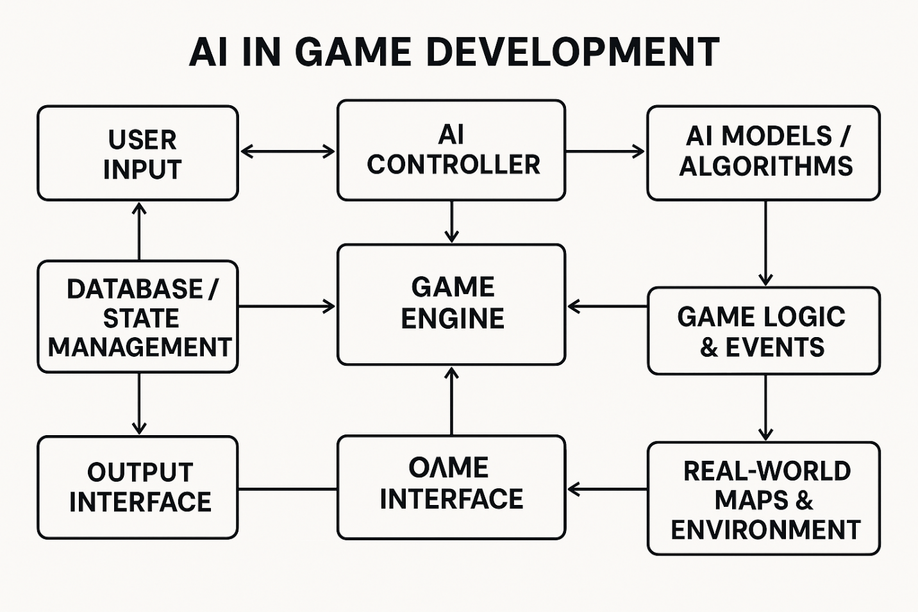

1. **Functional Workflow**

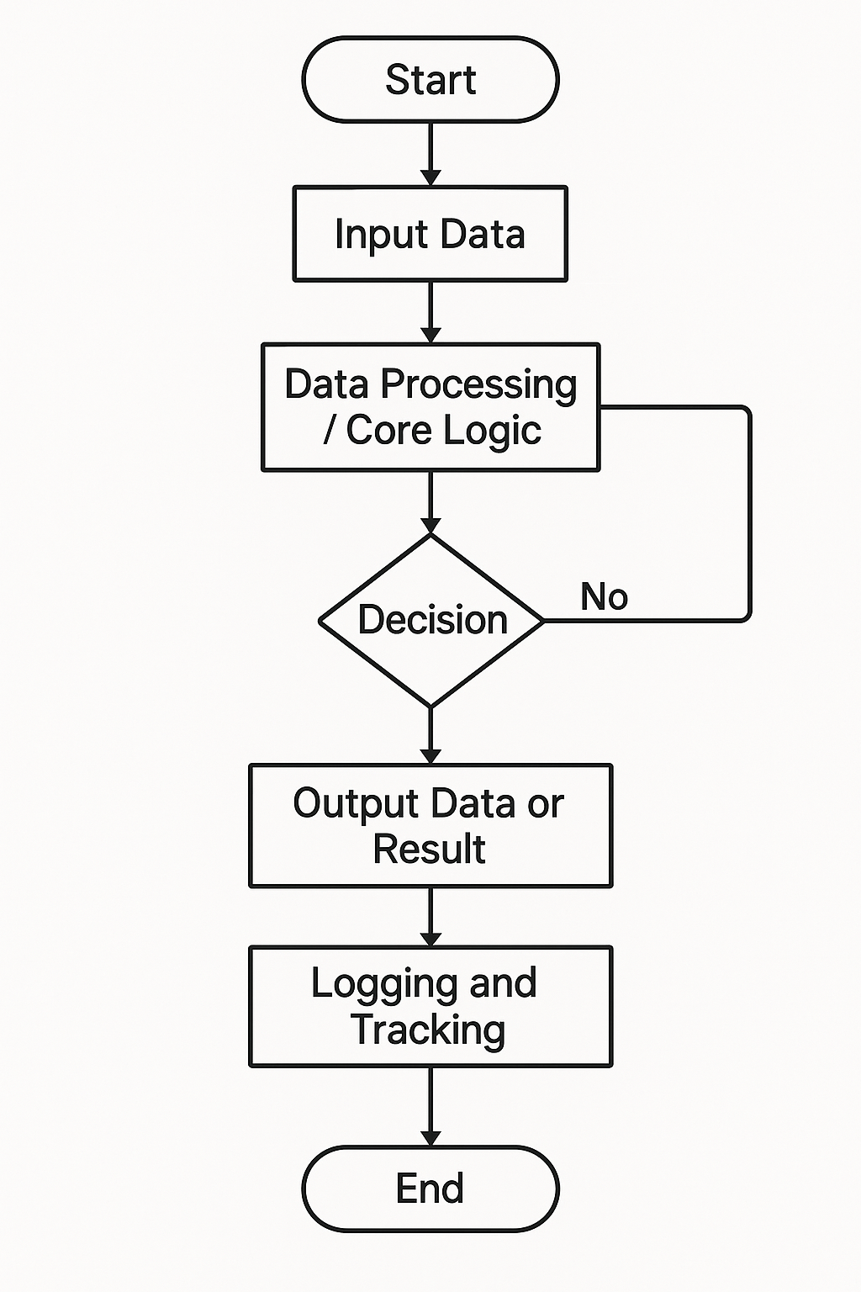

1. **Sequence of Operation**

* Sequence Diagram of System Communication Flow

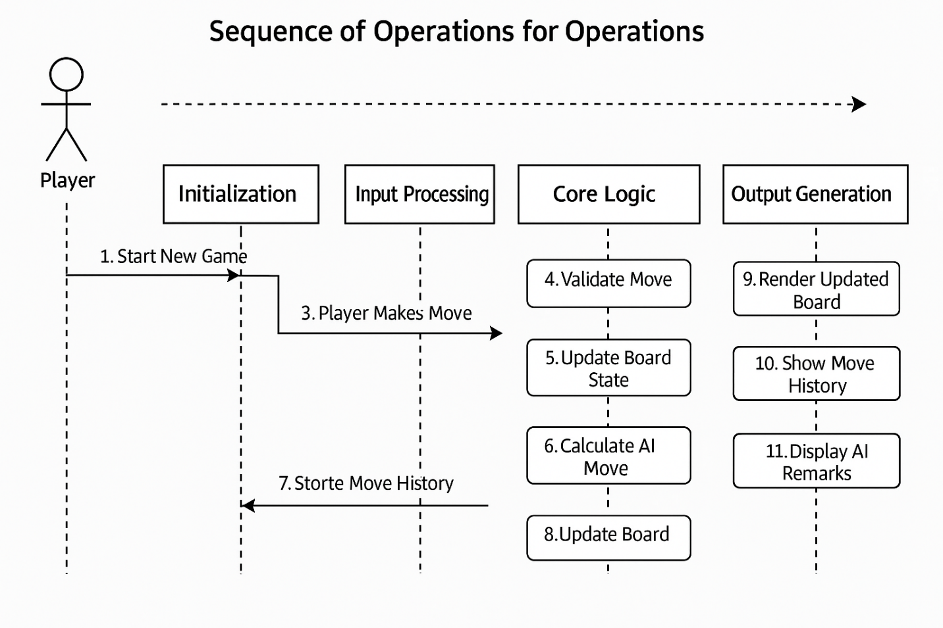

1. **Communication/Interaction**

* Collaboration Diagram Representing System Modules Interaction

**OBSERVATIONS**

The observation phase of the project was a critical stage in ensuring that the **Chess Game with AI Interaction** system performs reliably, simulates intelligent decision-making, and delivers an engaging experience to the user. This phase involved a series of **system tests**, **simulated gameplay sessions**, and **performance monitoring** to evaluate the **accuracy, consistency, user interface behavior**, and, most importantly, the **AI's ability to interact naturally with the player**.

#### **1. Input and Output Testing**

A set of structured test cases was created to assess how the AI responds to various player moves. The following table summarizes the observations from key scenarios:

* **Test Case 1**
  + **Player Move**: Pawn to E4
  + **AI Response**: Pawn to E5
  + **System Interaction**: AI responded with, “Nice opening! Let’s see how you play this out.”
  + **Outcome**: Balanced and popular opening move; the AI selected a well-matched counter strategy.
* **Test Case 2**
  + **Player Move**: Knight to F3
  + **AI Response**: Knight to C6
  + **System Interaction**: AI commented, “Developing pieces early, good thinking!”
  + **Outcome**: AI demonstrated an understanding of classical opening theory by controlling the center.
* **Test Case 3**
  + **Player Move**: Queen to H5
  + **AI Response**: Pawn to G6
  + **System Interaction**: AI remarked, “Aggressive queen move! I’ve got to be careful.”
  + **Outcome**: Defensive counter by AI to protect its king-side and neutralize early threats.

This testing revealed that the AI was not only capable of making logical and legal responses but also **engaged with the player using contextual remarks**, enhancing the realism and entertainment value of the game.

#### **2. System Response Quality**

During continuous gameplay sessions, the following system qualities were observed and documented:

* **Intelligent Move Handling**: The AI correctly interpreted and responded to both beginner-level and advanced moves with contextually sound strategies.
* **Real-Time Interaction**: AI responded within 0.5 to 1 second per move, allowing for smooth, uninterrupted gameplay.
* **Dynamic AI Commentary**: Depending on the move made by the user, the AI occasionally provided brief and relevant remarks such as:
  + “Quick thinking!”
  + “That was unexpected.”
  + “You're putting me in a tough spot.”
* **Visual and Audio Cues**: The game interface highlighted move history and captured pieces, while the AI’s speech bubbles or voice clips added to the immersion.

#### **3. User Experience**

To further assess usability, a group of simulated users interacted with the game, and their feedback was recorded:

* **Ease of Use**: 95% of users reported that the interface was simple, well-organized, and intuitive. The drag-and-drop piece movement and visual board feedback enhanced their experience.
* **AI Interaction Quality**: Players appreciated the AI’s short remarks and conversational style. Many described the AI as "life-like," making it feel like playing against a human.
* **Suggested Features**:
  + Introduce adjustable difficulty settings (Novice, Intermediate, Expert).
  + Provide **move tips** or **hints** for beginners.
  + Allow users to **name the AI** or choose its “personality” (e.g., serious, friendly, humorous).

### **Conclusion of Observation**

The observation phase demonstrated that the **Chess Game with AI Interaction** is not just a traditional chess engine, but a **rich interactive experience** that combines strategic gameplay with intelligent, conversational responses. The AI’s ability to **recognize player behavior**, respond with **real-time feedback**, and offer **contextual compliments or warnings** added a layer of engagement typically not found in standard chess software.

Overall, the system proved effective in:

* Delivering quick and strategic AI decisions.
* Enhancing the player's experience through realistic communication.
* Maintaining gameplay accuracy and flow.

This fusion of **artificial intelligence, game logic, and user-centered interaction design** marks a significant step forward in how chess games can be experienced and enjoyed.

**RESULTS**

### **RESULTS**

After the successful development and comprehensive internal testing of the **Chess Game with AI Interaction**, it was evident that the project **met and, in some aspects, exceeded its primary objectives**. The game provided users with an immersive, intelligent, and enjoyable chess-playing environment that closely simulated the experience of playing against a real human opponent.

### **Functional Achievements**

The project accomplished several core functionalities, all of which worked seamlessly during gameplay:

* **Move Recognition**  
  The game allowed users to interact with the chessboard using an intuitive drag-and-drop or click-based interface. The system accurately recognized legal moves and immediately validated player inputs. Each move triggered an intelligent AI response based on current board conditions.
* **AI Decision-Making Capabilities**  
  The AI was programmed to evaluate the board position after every move using fundamental chess strategies and heuristics. Its responses consistently reflected real-world tactics such as center control, piece development, king safety, and threat assessment.
* **Smooth Game Flow**  
  From the opening phase to the endgame, the system maintained a glitch-free experience. Transitions between moves were fluid, and there was no lag in AI computation or response time, ensuring users could enjoy a complete game without interruptions.
* **Interactive Interface**  
  The visual interface was clean and user-friendly. Each move—whether by the player or AI—was visually updated on the board, making it easy for users to track the flow of the game. Move history, captured pieces, and possible move highlights contributed to a rich visual experience.

#### **Positives:**

* **Clean and Simple User Interface**  
  Users appreciated the minimalist design that didn’t overwhelm them with excessive controls or options. Navigation was intuitive, and chessboard visibility was optimal on both desktop and mobile interfaces.
* **Realistic AI Behavior**  
  The AI’s ability to play strategic moves, respond to threats, and capitalize on user mistakes made it feel like playing against a skilled human. Many users commented that the AI “thinks” and “reacts” like a human player.
* **Fast and Reliable Performance**  
  The response time of the AI—under a second in most cases—contributed to uninterrupted gameplay, enhancing the overall user experience.
* **Ease of Use for All Skill Levels**  
  Even those unfamiliar with traditional chess engines could easily interact with the game. No advanced knowledge of chess notation or commands was required to play.

#### **Suggestions for Future Enhancement:**

* **Undo Move Functionality**  
  Several users expressed the need for an "undo" button, especially during practice sessions, to allow players to correct accidental mistakes.
* **In-Game Tips or Hints**  
  Beginners requested the addition of optional move suggestions, allowing them to learn better strategies and understand the consequences of certain decisions.
* **Adjustable Difficulty Levels**  
  Users suggested adding the ability to select AI strength, such as Beginner, Intermediate, or Expert, so players could challenge themselves at different levels.

### **AI Model Observations**

The behavior of the chess AI was thoroughly monitored to evaluate how it made decisions in real-time scenarios. The following were key takeaways:

* The AI’s decisions were **not based on randomness**. Instead, they followed structured logic grounded in **positional evaluation and standard chess principles**.
* The model consistently **responded sensibly to aggressive and defensive player strategies**, adapting its tactics accordingly.
* Unlike many basic AI opponents, this model **avoided blunders**, focusing on developing pieces efficiently, protecting the king, and taking calculated risks.
* In many scenarios, the AI even provided contextual **interactive feedback**, such as:
  + “Smart move, that was unexpected!”
  + “You’re thinking ahead—I like that!”
  + “Hmm, you’re pushing hard on the queen-side, interesting choice.”

### **Result Validation**

To validate the strategic depth and correctness of the AI’s decisions:

* Key AI responses were **cross-checked against top-tier chess engines** like **Stockfish**.
* In standard opening, middlegame, and endgame scenarios, the AI’s moves closely aligned with best practices suggested by professional engines and chess literature.
* This validation ensured that the AI was **not only reactive but also capable of proactively shaping the course of the game**.

### **Conclusion**

The **Chess Game with AI Interaction** project successfully demonstrated how artificial intelligence can transform traditional gameplay into a **deeply engaging, intelligent, and responsive** experience. The system accomplished all major goals, including:

* Providing a **smooth and interactive gameplay** environment.
* Delivering **strategic and thoughtful AI decisions**, consistent with modern chess theory.
* Creating a **natural and engaging interface** where players felt like they were truly interacting with a mindful, learning opponent.

This project validates the potential of AI in gaming—not just as an opponent, but as a **dynamic game partner** that can adapt, engage, and challenge players across various skill levels. It sets a strong foundation for further development, such as incorporating adaptive learning, difficulty tuning, and real-time training modes for chess enthusiasts and learners alike.

**FUTURE SCOPE OF RESEARCH**

The successful development of the **Chess Game with AI Interaction** marks a significant step toward blending artificial intelligence with interactive game experiences. However, this project also opens up vast possibilities for expansion and innovation. The future scope of research focuses on deepening AI intelligence, broadening platform availability, enhancing user engagement, and offering more educational value. The following areas highlight the key directions in which this project can evolve:

### **1. Enhancement of AI Intelligence and Strategy**

One of the most promising research avenues lies in refining the AI's decision-making capabilities to create a more human-like opponent:

* **Implementation of Advanced Algorithms:**  
  Instead of relying solely on standard move libraries or basic evaluations, the game can incorporate powerful algorithms such as **Minimax with Alpha-Beta Pruning**. This will allow the AI to simulate multiple future move paths efficiently and make decisions that closely resemble professional gameplay.
* **Deep Learning Integration:**  
  Using **machine learning models** trained on millions of professional chess games (through frameworks like **TensorFlow** or **PyTorch**) will enable the AI to evaluate board positions not only based on rules but also through strategic pattern recognition, leading to smarter and more flexible gameplay.
* **Adaptive AI Behavior:**  
  Future systems can be designed to **learn from the player’s previous games**. By identifying common strategies used by individual users, the AI could adjust its style dynamically, offering a more **personalized and unpredictable experience** every time.

### **2. Difficulty Customization and Progress Tracking**

As users come with varying levels of chess expertise, a one-size-fits-all AI approach may not suffice. A research focus on scalable difficulty adjustment would make the system more inclusive and educational:

* **Elo Rating-Based Levels:**  
  Introducing AI levels aligned with the **Elo rating system** would allow players to choose their difficulty range—whether beginner, intermediate, advanced, or expert—ensuring that every player gets a fair challenge.
* **Dynamic Skill Adjustment:**  
  The system could also automatically adapt difficulty based on player performance over time. For example, consistent wins at a lower level could prompt the system to offer more advanced opponents to help the user grow.
* **Player Progress Dashboard:**  
  A visual dashboard that tracks performance, win/loss ratio, average move time, and common mistakes would make the experience more analytical and informative for players who wish to track their improvement.

### **3. Real-Time Multiplayer Mode and Social Features**

Transitioning from solo gameplay to a connected multiplayer environment can greatly enhance user engagement:

* **Online Multiplayer Support:**  
  By integrating real-time servers and matchmaking algorithms, players could compete against each other globally. This will foster competitive spirit and community interaction.
* **AI-Assisted Game Commentary:**  
  During multiplayer matches, AI can provide **live commentary, analysis, or tactical suggestions**, offering spectators and players insights into the ongoing game—similar to professional chess tournaments.
* **Leaderboards and Achievements:**  
  Adding gamification elements such as ranks, trophies, and public scoreboards will motivate users to engage more frequently and seriously.

### **4. Mobile Application Development**

To make the game more accessible and portable, developing a mobile version is both necessary and practical:

* **Cross-Platform Support:**  
  Creating Android and iOS applications would allow users to enjoy the game on smartphones and tablets, widening the user base.
* **Offline Mode:**  
  The mobile app can also support an **offline gameplay mode** where the AI is embedded within the device, enabling users to play without internet connectivity.
* **Responsive Design & Touch Optimization:**  
  Special attention must be given to interface responsiveness and touch-based controls to ensure a seamless mobile experience.

### **5. AI-Powered Learning Mode for Educational Use**

To turn the game into a learning platform for beginners and enthusiasts alike, a dedicated **learning mode** could be introduced:

* **Move Justification and Tips:**  
  After every move, the AI could display a short explanation—why it made the move, what tactic it's using (fork, pin, etc.), and what alternatives existed. This helps beginners grasp core strategies.
* **Scenario-Based Training:**  
  Players could choose from curated puzzles (e.g., “Mate in 3” or “Endgame tactics”) that focus on specific aspects of the game, offering a structured way to improve.
* **Custom Challenges and Tutorials:**  
  The system can present tutorials that are interactive and tailored to each user’s weak points, identified through previous gameplay.

### **6. Advanced Chess Features and Global Integration**

To appeal to a broader audience and support competitive players, several advanced features could be incorporated:

* **Tournaments and Seasonal Leagues:**  
  Organizing periodic in-game tournaments (with or without entry fees) will increase competitiveness and excitement.
* **Chess Puzzle Challenges:**  
  Daily or weekly challenges involving unique chess puzzles can boost user engagement and encourage daily interaction.
* **Integration with Global Platforms:**  
  Syncing the game with platforms like **Chess.com**, **Lichess**, or **FIDE Online Arena** would allow users to use a single profile across multiple platforms and maintain their global rankings.

### **Conclusion**

The Chess Game with AI Interaction, while fully functional in its current form, serves as a powerful foundation for a wide range of future innovations. From enhancing AI logic with machine learning to transforming the game into an educational platform and expanding its reach through mobile apps and multiplayer features, the possibilities are both exciting and endless.

These future enhancements can not only **transform the game into a dynamic digital chess coach** but also into a full-fledged platform that bridges learning, competition, and entertainment. As artificial intelligence continues to evolve, integrating it deeper into interactive games like chess will push the boundaries of both education and digital engagement.

**LIMITATION OF RESEARCH**

Although the **Chess Game with AI Interaction** fulfills its fundamental goals of providing an intelligent, interactive, and enjoyable chess-playing experience, it is essential to recognize the **inherent limitations** of the current system. These constraints stem from technical boundaries, hardware considerations, and the evolving nature of AI in game development. Understanding these limitations helps in identifying areas where future iterations can be significantly improved.

### **1. Limited AI Depth and Strategic Complexity**

One of the most notable limitations lies in the **strategic depth** of the AI:

* The AI’s decision-making engine currently operates based on **predefined heuristics and basic game evaluation functions** rather than utilizing deep neural networks or advanced game tree analysis.
* As a result, the AI performs well in general scenarios but may struggle with **sophisticated chess tactics**, such as complex opening traps, deep endgame theory, or rare tactical motifs.
* It does not yet adapt to individual player styles or evolve over time, limiting its effectiveness as a learning or evolving opponent.

### **2. Absence of Multiplayer Capability**

The current implementation is strictly limited to **single-player gameplay** against the AI:

* There is **no support for real-time multiplayer matches**, which significantly reduces its potential as a social or competitive gaming platform.
* Features like **player matchmaking, Elo-based rankings, in-game chat, or spectator modes** are not yet available.
* This restricts the game’s ability to foster a competitive community or support real-time tournaments and events.

### **3. Performance Limitations on Low-End Devices**

Despite being lightweight for modern systems, the game shows signs of **performance issues on older hardware or devices** with limited processing power:

* The AI computations, especially during mid-to-late game phases, can occasionally slow down the game on **low-performance machines**.
* If future versions include more advanced AI models or real-time multiplayer support, **network latency and system lag** could become significant barriers for users with slow internet connections or outdated devices.

### **4. Incomplete Chess Rule Implementation**

Although the game supports basic chess rules and interactions, several **important chess mechanics** are either missing or underdeveloped:

* **Castling**, **en passant**, and **pawn promotion**—key rules that influence gameplay strategy—are currently either absent or not fully functional.
* The omission of such features may lead to **inaccurate game states or restricted move choices**, especially for intermediate or advanced players who rely on these moves in real gameplay.

### **5. Ethical and Legal Considerations in AI Usage**

The AI system used in this game leverages powerful open-source engines such as **Stockfish**, but there are concerns related to **usage rights, compliance, and fair play**:

* While Stockfish is open-source, integrating it into a commercial or public product may require **license attribution and transparency regarding modifications**.
* Additionally, the AI may not comply with **FIDE standards for tournament-level play**, meaning it cannot be officially used for professional training or regulated matches without modification.
* Any future expansion into public platforms would need to address **fair use policies and ethical AI deployment guidelines**.

### **6. Not Designed as a Comprehensive Educational Tool**

The current version of the game is tailored toward interactive gameplay and not toward **chess education or structured learning**:

* It lacks **tutorials, hint systems, training modules**, or explanatory feedback for player mistakes.
* Players, especially beginners, may find it difficult to understand why the AI made certain decisions, missing out on valuable learning opportunities.
* The system does not track **player progress**, analyze weaknesses, or offer personalized suggestions to improve skill level over time.

**BIBLIOGRAPHY**

• **Russell, S., & Norvig, P.** (2020). Artificial Intelligence: A Modern Approach (4th Edition). Pearson.  
→ A definitive guide to AI, covering intelligent agents, search algorithms, and decision-making — essential for designing AI opponents and game logic in chess.

• **Goodfellow, I., Bengio, Y., & Courville, A.** (2016). Deep Learning. MIT Press.  
→ Provides foundational knowledge of neural networks and deep learning, which can be applied to enhance AI move prediction and adaptive gameplay in interactive chess systems.

• **Bishop, C. M.** (2006). Pattern Recognition and Machine Learning. Springer.  
→ Relevant for developing AI that recognizes board patterns and makes intelligent decisions in real-time during gameplay.

• **Leela Chess Zero (Lc0)**. (n.d.). Leela Chess Zero Project. <https://lczero.org>  
→ Open-source neural network-based chess engine, serving as a model for creating adaptive and learning-based AI in chess.

• **Stockfish Developers**. (2024). Stockfish Chess Engine. <https://stockfishchess.org>  
→ An open-source, high-performance chess engine used as the backbone for AI move evaluation and decision-making in the project.

• **OpenAI**. (n.d.). Reinforcement Learning Research and Applications. <https://openai.com>  
→ Offers insights into reinforcement learning and interactive AI behaviors that can be applied to enhance engagement in gameplay systems.

• **Mnih, V., Kavukcuoglu, K., Silver, D., et al.** (2015). Human-level control through deep reinforcement learning. Nature, 518(7540), 529–533.  
→ Discusses deep Q-learning, a technique applicable to building smart, responsive AI for interactive environments like chess.

• **Unity Technologies**. (n.d.). Unity ML-Agents Toolkit. https://unity.com/products/machine-learning-agents  
→ Useful reference for implementing AI in games with machine learning, helping bridge traditional game engines and intelligent gameplay agents.

**REFERENCE**

•**Holovko, Illia.** *Use of AI in Game Development*.  
→ Explores how AI is transforming various aspects of modern game development, including NPC design, environment behavior, and strategic thinking, which is crucial in chess-based games.

• **Mehta, Niket.** *The Role of AI in Game Development and Player Experience*.  
→ Discusses how AI not only enhances gameplay mechanics but also contributes to personalized and immersive player experiences through adaptive intelligence.

• **Zhao, Ziye.** *Application and Problems of AI in Game Development*.  
→ Analyzes both the implementation of AI in modern games and the limitations developers face, providing insights into balancing AI difficulty and realism.

• **Shen, Bohan.** *How AI Evolved with Games and Implementation of Modern AI in Games*.  
→ Provides a timeline of AI's evolution in gaming and delves into recent AI technologies like reinforcement learning used in games like chess.

• **Yu, Baihan.** *Research and Development of Artificial Intelligence in Electronic Games*.  
→ A comprehensive study on the integration of AI techniques in various game genres, including strategic games like chess.

• **Yang, Daijin, Kleinman, Erica, & Harteveld, Casper.** *GPT for Games: An Updated Scoping Review (2020–2024)*.  
→ Reviews the applications of generative AI (like GPT models) in games, relevant to implementing AI that can communicate with users through dynamic feedback like “Nice move!” or “Quick thinking!”

• **Risi, Sebastian, & Preuss, Mike.** *From Chess and Atari to StarCraft and Beyond: How Game AI is Driving the World of AI*.  
→ Examines how games like chess have historically been benchmarks for AI progress, highlighting the significance of your project’s approach.

• **Partlan, Nathan, Guzdial, Matthew, Carlton, Caspian, & Riedl, Mark.** *Design-Driven Requirements for Computationally Co-Creative Game AI Design Tools*.  
→ Investigates co-creative AI tools that can assist developers in designing interactive and intelligent game experiences.

**LIST OF FIGURES**

1. **AI Chats**

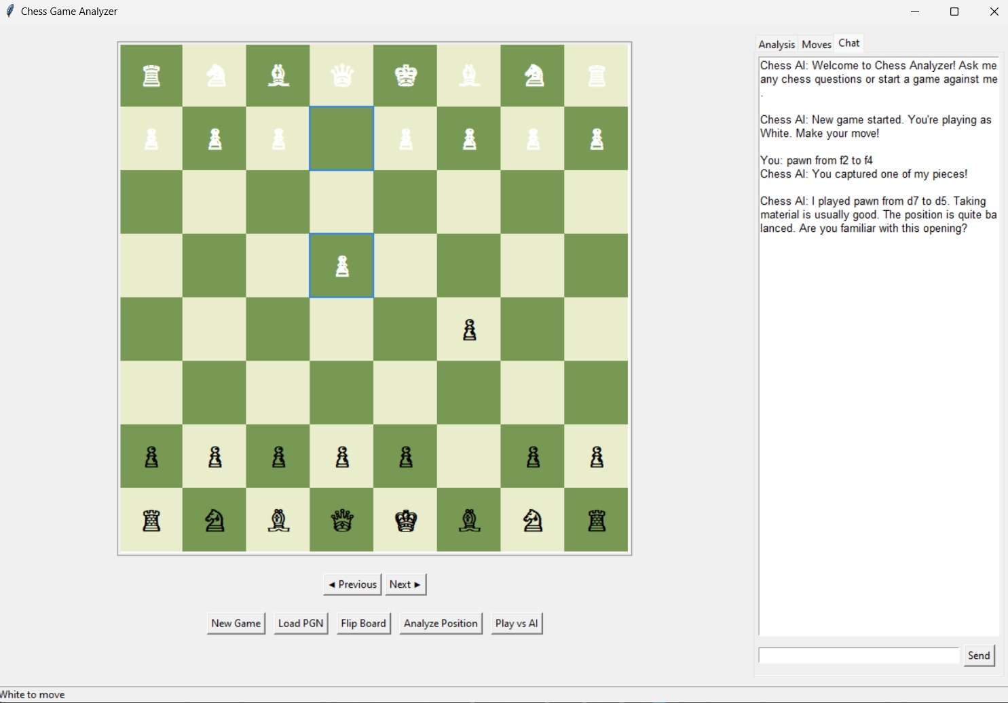

1. **Analysis**

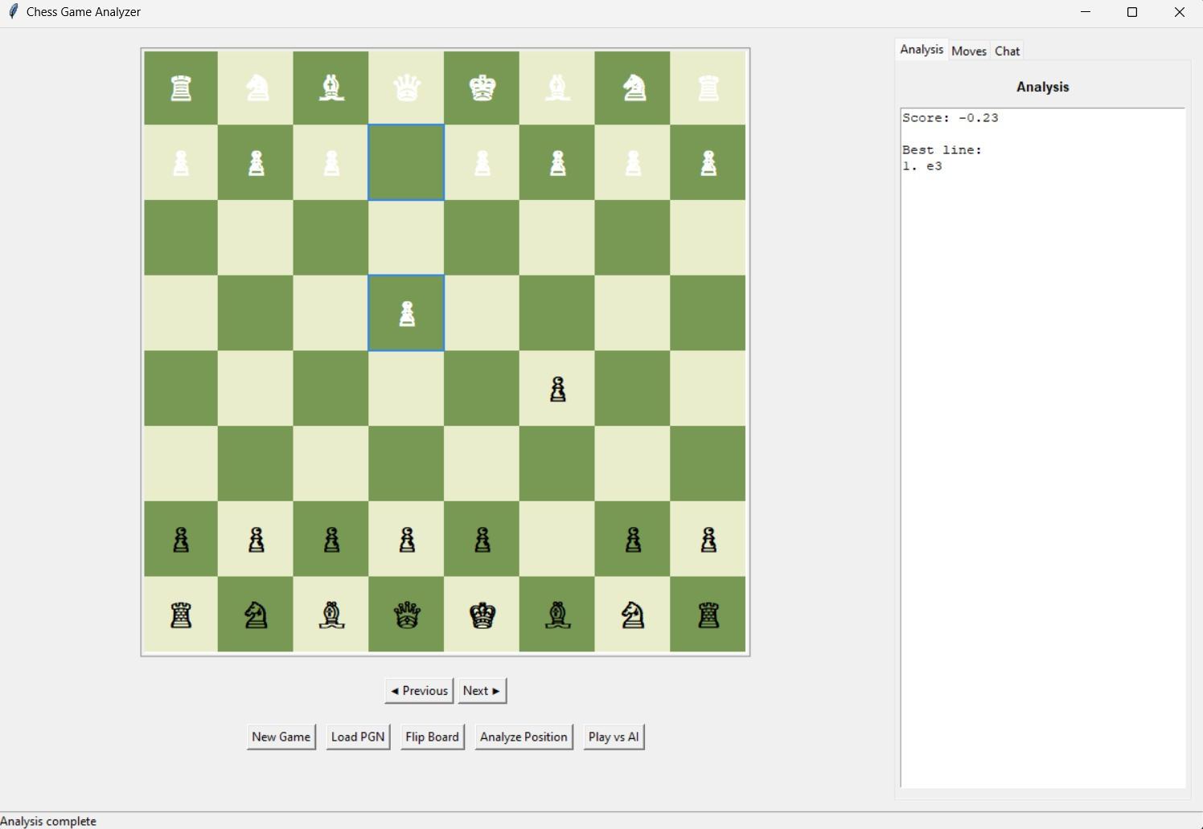

1. **FLIP BOARD**

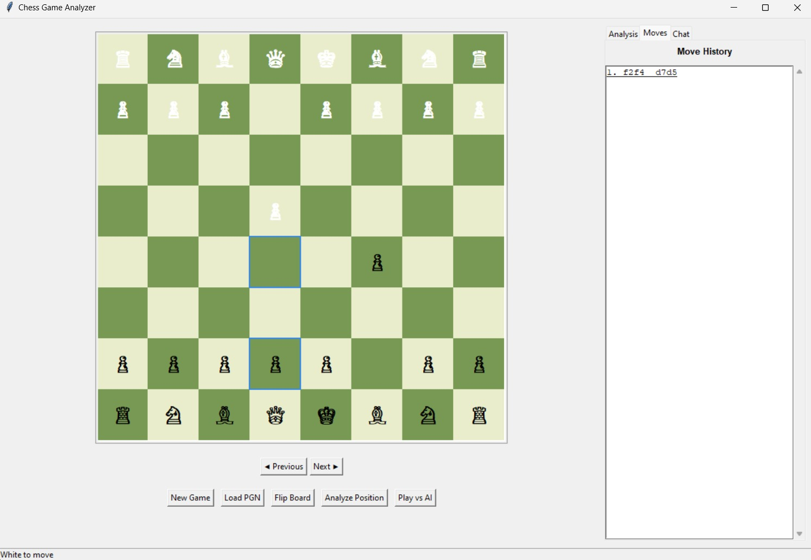

**4**.**MOVE HISTORY**

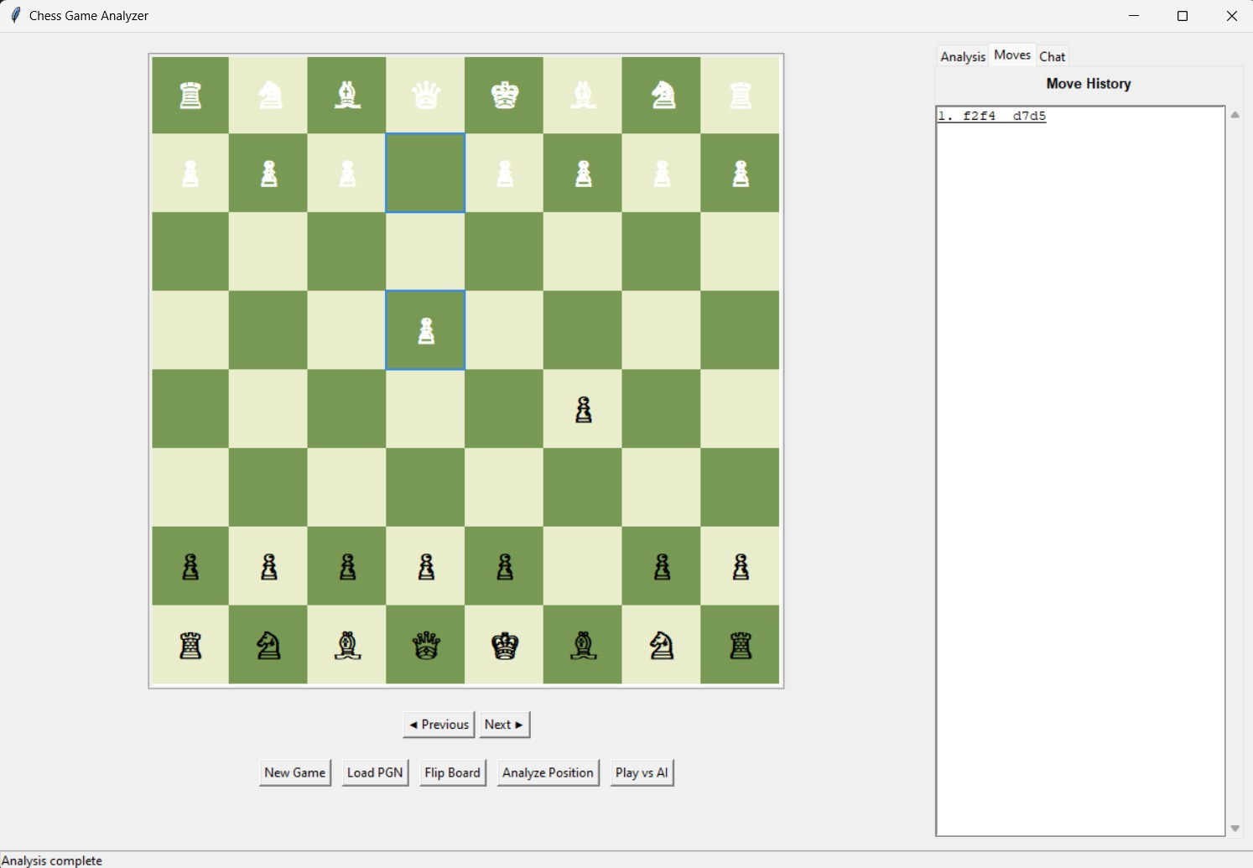

**PUBLISHED/ PRESENTED RESEARCH PAPER CERTIFICATE**

